Sensor Failure Detector

The task:

There is a motor and gearbox assembly with two sensors: an incremental quadrature encoder and a potentiometer.

The encoder is on the motor shaft (i.e. the input to the gearbox), and the potentiometer is on the output shaft of the gearbox.

There is a 30:1 gear reduction between the encoder and potentiometer.

The encoder generates 2048 counts per revolution of the motor.

The reading from the encoder is presented to you as a signed number whose value is in encoder counts.

The reading from the potentiometer is a voltage from 0 to 5 V, which cycles linearly over each revolution by a saw tooth wave as pictured in Figure 1.

This voltage is read by an 8- bit A/D converter and presented to you as an unsigned number, where a value of 0 corresponds to 0V and a value of 255 corresponds to 5V.

The potentiometer is an absolute sensor - at boot time (the beginning of the data file), it has a non-zero value corresponding to the current position of the output shaft.

However, the encoder always reads zero at boot time, so there is a fixed offset between the two sensors that must be computed every time you start up.
Assume that both sensors are functioning correctly during the first 0.5 seconds of each data file.
This period may be used to initialize and/or calibrate your algorithms.
Write a command-line program that takes as its first argument a path to a text file with a series of readings from each sensor. The program should compare the two sensor data series and print to the console a single message indicating whether or not an error was detected. If an error is detected, the time at which an error was first detected should also be printed.

Input Data:

Each sensor data file is a text file with lines of the format:

time encoder potentiometer

where:
time is in floating-point seconds,
encoder is a signed integer
and potentiometer is an unsigned integer.
The sensor readings are for a motor moving through the trajectory pictured in Figure 2.

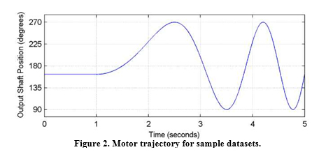

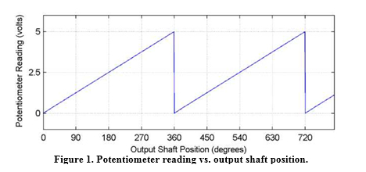
Sensor Failure Detector is the console application written in C++, using Visual Studio 2015 environment, standard C/C++ input and output procedures, and STL string container class.
The purpose of the application is to detect measurement failure based on the comparison of two measurements: the angle measurement made by the encoder, and the angle measurement made by the potentiometer (voltmeter).
The application reads the input file of data (time, encoder data, voltmeter data) and calculates the difference between encoder and voltmeter data measurements.
The current voltmeter data measurement in degrees is:
fCurrentAngleByVoltmeter = iCurrentVoltage * BYTE_TO_DEGREES;
Where:
iCurrentVoltage is the data read from the file,
BYTE_TO_DEGREES it the constant value equal to 360/255.
The current encoder data measurement in degrees is:
fCurrentAngleByEncoder = fInitialAngle + iCurrentRotation / COUNTS_TO_DEGREES;
Where:
iCurrentRotation is the data read from the file,
COUNT_TO_DEGREES is the constant value equal to 2048*30/360 (see the task guidelines),
fInitialAngle is the difference between the real angle (measured by the voltmeter) and the angle measured by the Encoder at the first moment (we assume that encoder measurement at first is 0).
After calibration, however, we use the corrected value of an initial angle, i.e. the average value.
The input data file reading loop consists of 2 parts:

1). Reading the data before 0.5 seconds, when we assume both sensors work correctly, and we use these measurements for the calibration.
We need to calculate 2 values at that time:
a). fThreshold – the maximal possible difference between the angle measured by encoder and the angle measured by voltmeter at the same moment.
b). Trusted Standard Deviation of the measure differences (the ideal, or expected, value of the difference is 0).
The Threshold value is the sum of maximal voltmeter deviation (i.e. the difference between min and max voltmeter measures in degrees for the time between 0 and 0.5 seconds) and maximal encoder deviation (i.e. the difference between min and max encoder measures in degrees for the time between 0 and 0.5 seconds).
The minimal possible value of the Threshold, however, cannot be less than the voltmeter inaccuracy, i.e. 360/255 = 1.41 degrees.
The Trusted Standard Deviation is calculated using the formula:
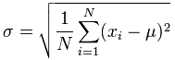
Where:
N is the measurements quantity from 0 to 0.5 seconds period,
Xi is the real difference between encoder measure and voltmeter measure in degrees,
m = 0 (the ideal, or expected, difference between encoder measure and voltmeter measure in degrees).
Trusted Standard Deviation, however, cannot be less than the voltmeter inaccuracy.

2). Reading the data after 0.5 seconds to the end of the file.
During that time, we calculate the difference between encoder measure and voltmeter measure in degrees for each moment. If the current difference is more than the Threshold, we remember that moment and set the failure flag.
We cannot make the decision about sensor failure yet, because it can be just an occasional spike on one of the sensors, - that is why we need to calculate Real Standard Deviation as well, using the same formula as for Trusted Standard Deviation, but for times between 0.5 seconds and the time stamp at the end of the file.
3). After the whole file is read, the decision is made based on 2 factors:
If Real Standard Deviation is more than Trusted Standard Deviation, AND the failure flag is set, the measurements are considered as inaccurate since the moment when the failure flag was set.
In any other cases the measurements are considered as accurate.

